The Maryland Watermen's Association's
52nd East Coast Commercial
Set-up Days  Wednesday, January 13  8 AM to 5 PM  Thursday, January 14  8 AM to 8 PM | Public Show Days  Friday, January 15  10 AM to 5 PM  Saturday, January 16  10 AM to 5 PM | Move Out Days  Saturday, January 16 5 PM to 9 PM
Fishermen’s and Aquaculture Trade Exposition
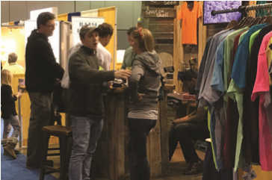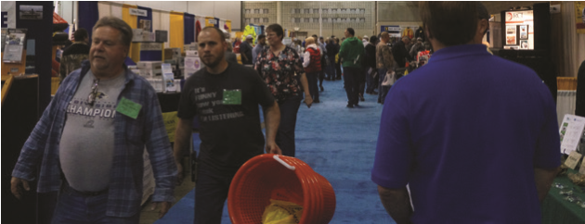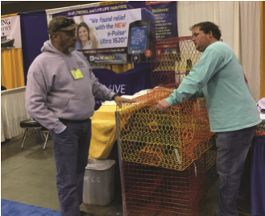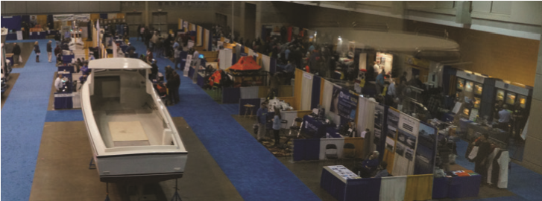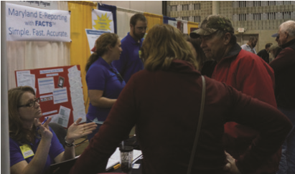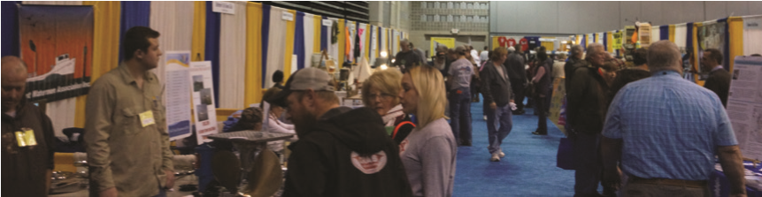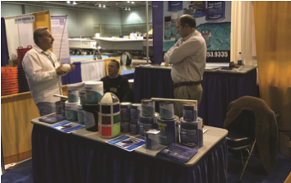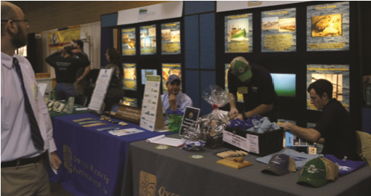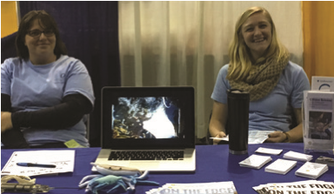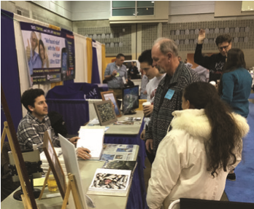
Roland E. Powell Convention Center Ocean City, Maryland
January 15th & 16th, 2027
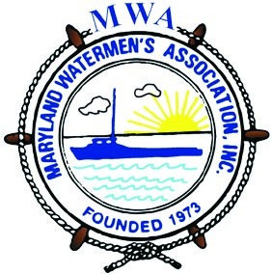
Show Dates and Hours
Message from the President
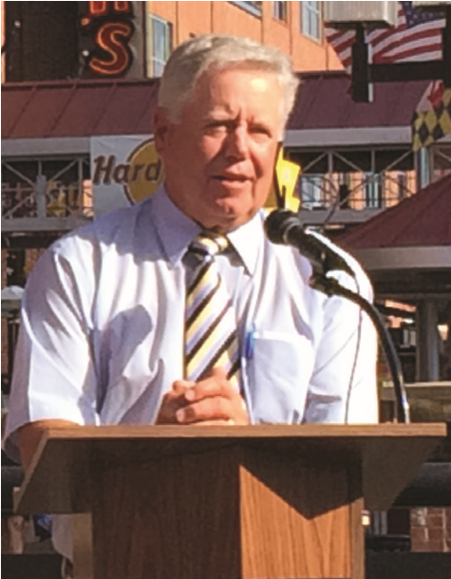
The 52nd Annual East Coast Commercial Fishermen’s and Aquaculture Trade Expo will be held on January 15-16, 2027 in Ocean City, Maryland at the Ocean City Convention Center. It promises to be another exciting event as after talking with our loyal vendors all agreed that a two-day event would work better. We have already heard from many returning and prospective vendors. There is a lot of great enthusiastic interest in this year’s upcoming show, with new technologies. There are many exciting seminars and exhibits, and new products planned for our commercial watermen, charter boat captains, and working aquaculture industry.
We have started the planning process early and already have a number of returning vendors and several first -time exhibitors. Since our last show, many things have transpired through legislation, changes in federal and state regulations, and quotas to the fisheries. This expo will continue to reconnect the commercial watermen and catch up on the past year so we can prepare for the 2027 legislative session. Let us put together the needs and embrace opportunities to continue to ensure that our industry stays alive and continues to thrive.

Expo 2026 was a success, and I know that the 52nd Expo 2027 will be even bigger and better. We welcome exhibitors with boats, engines, gear, and industry products along with valuable educational seminars and industry updates.
With that said, I would like to invite you to our 52nd Annual East Coast Commercial Fishermen’s and Aquaculture Trade Expo. Mark your calendars, make your reservation early to get discounts on hotels and we hope to see you there!
Stay Safe in Your Travels.

Robert T. Brown, Sr.
President, Maryland Watermen’s Association

2027 Exhibit Space Rates
(Prices stayed the same)
10x10 Inside 10x10 Corner Bulk Space Boats/ Booth $940.00 Booth $1045.00 Trucks $3.75/sq. ft
Booth space rates include an 8 ft. pipe and drape with 3 ft high side rails and one draped 6 ft table. All exhibitors receive, free of charge:

- Sign with company name
- 1 110v electrical outlet
- 2 chairs
- 1 waste basket
- Crate storage
- Security
- Cleaning of aisles

East Coast Commercial Fishermen's and
Aquaculture Trade Exposition Layout
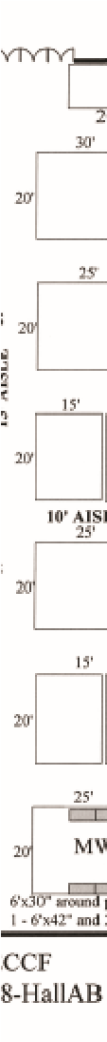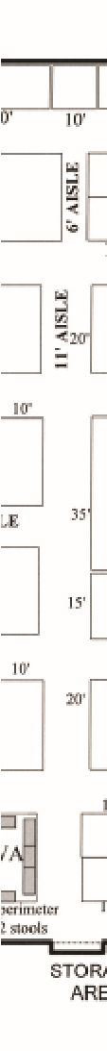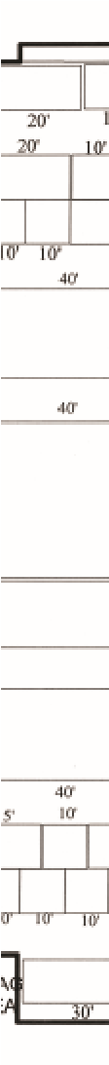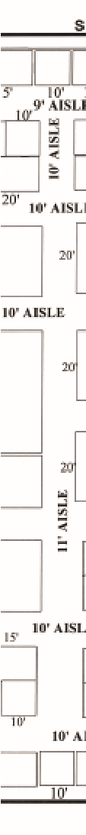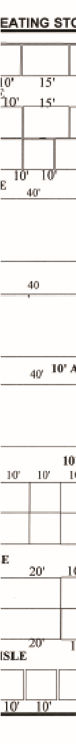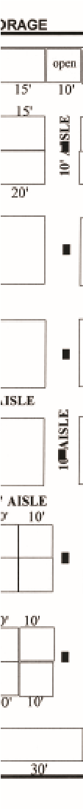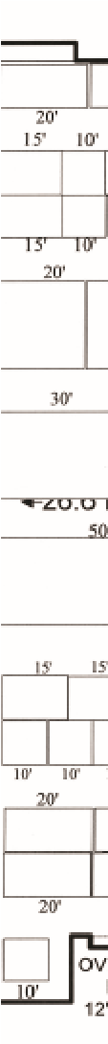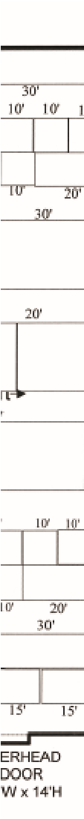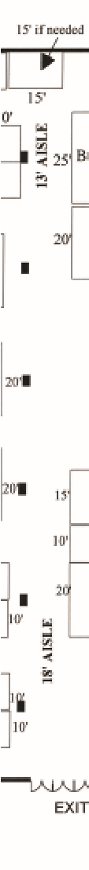
(Floor layout subject to change)

Convention Hall

Ideal Exhibition Space
The Convention Center is great! The ground level exhibition space is large enough for the biggest of displays and is an ideal showplace for your products and services. Aisleways are carpeted with color-coordinated draping to provide an attractive and comfortable business atmosphere.

A Showcase for Your Products
Our expo has the reputation as being a trade show “where people come to buy.” You can expect show visitors to be looking to buy all types of gear, equipment and services related to in-shore and off-shore fisheries, as well as all facets of the aquaculture industry. Call us about first-time exhibition incentives.

Accommodations and Hospitality
Holiday Inn Ocean Front has been designated as Expo Headquarters for 2027. Rooms have been reserved and your reservation information will be mailed to you with the set-up bulletin. Please make reservations early as to receive the discounted rate.
We will entertain our exhibitors with a cocktail party and auction featuring seafood hors d’oeuvres on Friday, January 15th at the Ocean City Convention Center.

Advertising

Publications and Direct Mail
Advertisements will be placed in National Fisherman, the Watermen’s Gazette, the Salty Dog and Boats & Harbor, as well as other newsletters and publications relating to commercial fishing, sportfishing, and aquaculture. More than 10,000 brochures will be mailed directly to licensed watermen, sportfishermen, Aguaculturists and industry-related associations on the East Coast. The promotional brochure will contain detailed show information designed to boost attendance and increase your opportunity for sales.
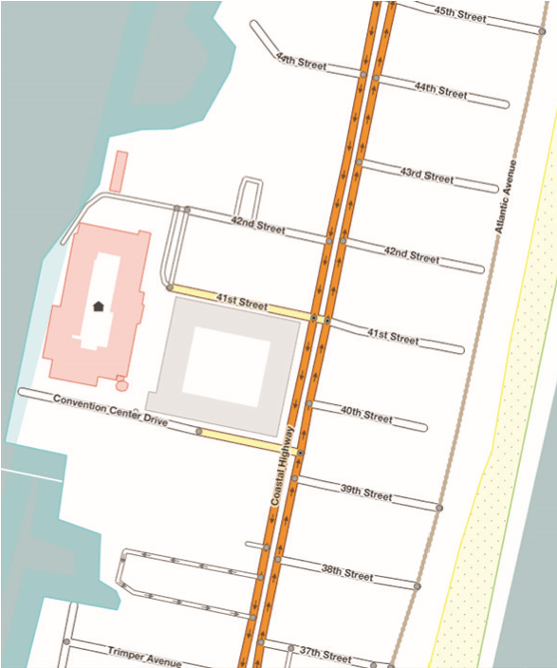
Easy Access Ocean City has excellent access…
Roland E. Powell
Convention Center
- Centrally located near most major East
Coast cities
- Five hours from New York and Richmond
- Less than three hours from Baltimore, Washington, D.C., and Philadelphia

Air service includes:
Baltimore/Washington International and Philadelphia International airports are within a 3-hour drive. The Salisbury-Ocean City/ Wicomico Regional Air- 21842 port (SBY) is just 30 minutes away

The convention center is located at:
4001 Coastal Hwy, Ocean City, MD

For further information on exhibiting and profiting at the 52nd East
Coast Commercial Fishermen’s and Aquaculture Trade Expo contact:
Maryland Watermen's Association
1805A Virginia Street
Annapolis, MD 21401
(410) 216-6610 or (202)-580-9377
www.marylandwatermen.com admin@marylandwatermen.com
Robert.t.brown@shopcove.net
Rbrown@marylandwatermen.com

